PRO PER CLINIC

PROGRAM DESCRIPTION | The Pro Per Clinic was developed to assist individuals representing themselves in Family Law and limited Probate matters. The Pro Per Clinic can assist you with the following issues:  WORKSHOPS SAMPLE PACKETS REVIEW ONLY  Dissolution Emancipation Domestic Violence  Legal Separation Civil Name Change Civil Harassment  Nullity Step-Parent Adoption Elder Abuse  1st Time Custody All Family Law  1st Time Visitation Limited Civil  Declaration of Disclosure Small Claims  DOCUMENT REVIEW:  You must bring your sample packet to have your document reviewed.  Workshop schedules are available at the courthouse or online.
ADDRESS/ EMAIL  TELEPHONE | 180 E. Weber Ave. Suite 105, Stockton, CA 95202 selfhelp@sjcourts.org  (209)992-5283
WEBSITE | www.sjcourts.org/self-help/pro-per-clinic/
HOURS | Monday – Friday from 8:00am – 2:00pm.
COSTS/FEES | There are no costs or fees to use the services of the Pro Per Clinic.
WAITING TIME | Your wait time may vary depending on when you arrive at the Clinic and the number of people already being helped.
WHAT TO EXPECT AND  BRING WITH YOU? | When you arrive you will need to sign in or register at the window for a workshop. Have a seat and wait for your name to be called. Clinic staff will discuss the issues you need help with, help you to understand the court system, and provide instructions on completing the necessary forms. You must bring a copy of all court documents relating to your case organized by date.  Do not bring children to the Clinic. Often times the issues that will be discussed are not appropriate for children to hear.  Please note that the Pro Per Clinic does not provide legal advice and will not represent you in court. The Clinic is available to both parties.
HOW DO I GET THERE? | 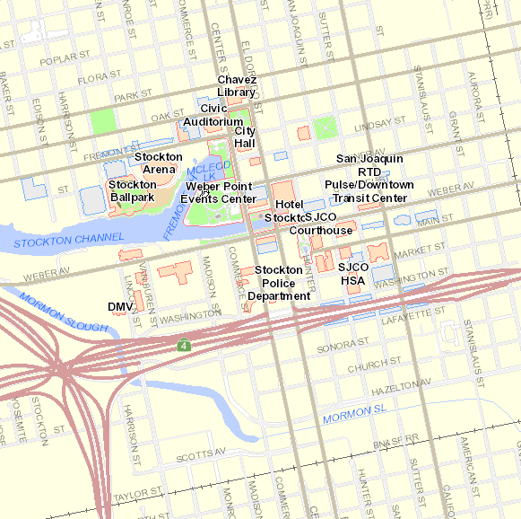

FUTURE COURT DATES:

DATE/TIME DEPARTMENT CASE NUMBER
________________________ _________________ _______________________________
________________________ _________________ _______________________________
________________________ _________________ _______________________________

UPCOMING APPOINTMENTS:

AGENCY/PROGRAM DATE/TIME
________________________________________ ____________________________
________________________________________ ____________________________
________________________________________ ____________________________

NOTES:
__________________________________________________________________________________________________________________________________________________________________________________________________________________________________________________________________________________________________________________________________________________________________________________________

